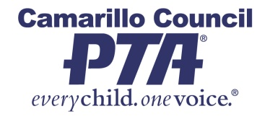

Honorary Service Award*
Nomination Form for YOUR SCHOOL NAME HERE
The Honorary Service Award Selection Committee requests that members of the YOUR PTA NAME HERE assist in the selection of deserving recipients for recognition at a special PTA event. Nominated individuals or organizations who have made significant contributions to the well being of children, youth or families at YOUR SCHOOL NAME HERE can be considered for this award. Current members, officers teachers and administrators may also be considered.
*Honorary Service Award Program includes the Honorary Service Award (HSA), Continuing Service Award (CSA), Golden Oak Service Award (California’s highest honor), Very Special Person (VSP), Outstanding Teacher Award (OSA), Outstanding Administrator Award (OAA) and Donations in the name of the individual or organization. All award information can be found online by visiting www.capta.org

HONORARY SERVICE AWARD PROGRAM
- - - - - - - -Please Print - - - - - - - -
Name of individual nominated:
Title or position:
Name of organization nominated:
Contact Person:
Address:
Telephone: (____)____________________ E-Mail:______________________________
Name of person submitting the nomination:
Telephone: (____)____________________ E-Mail:______________________________ Date:____________
Reason for Nomination (attach a page for additional space):_______________________________________________

All nominations will be considered. The HSA Selection Committee will select the recipient(s).
Nominations are due by ENTER DATE DUE FOR YOUR UNIT
Please return this form to:
Enter Name - HSA Committee Chair - Enter Your PTA Name Here
Email: Enter Mailing Address: Enter Mailing Address

